**Name:Vaishali Bharat Sapkal**

**Roll no:130**

**Practical 5:**

**Use git pull to get your partners change into your repository.verify that you have the new file.**

comp@com135 MINGW64 ~ (master)

$ git clone https://github.com/VAISHALI123sapkal/HOME.git

Cloning into 'HOME'...

remote: Enumerating objects: 3, done.

remote: Counting objects: 100% (3/3), done.

remote: Total 3 (delta 0), reused 0 (delta 0), pack-reused 0

Receiving objects: 100% (3/3), done.

comp@com135 MINGW64 ~ (master)

$ cd HOME

comp@com135 MINGW64 ~/HOME (main)

$ git pull https://github.com/VAISHALI123sapkal/HOME.git

remote: Enumerating objects: 4, done.

remote: Counting objects: 100% (4/4), done.

remote: Compressing objects: 100% (3/3), done.

remote: Total 3 (delta 0), reused 0 (delta 0), pack-reused 0

Unpacking objects: 100% (3/3), 1.71 MiB | 1.38 MiB/s, done.

From https://github.com/VAISHALI123sapkal/HOME

* branch HEAD -> FETCH_HEAD

Updating 2a52212..842d35e

Fast-forward

Python Practicals.pdf | Bin 0 -> 2596456 bytes

1 file changed, 0 insertions(+), 0 deletions(-)

create mode 100644 Python Practicals.pdf

comp@com135 MINGW64 ~/HOME (main)

$ git pull https://github.com/VAISHALI123sapkal/HOME.git

remote: Enumerating objects: 5, done.

remote: Counting objects: 100% (5/5), done.

remote: Compressing objects: 100% (4/4), done.

remote: Total 4 (delta 0), reused 0 (delta 0), pack-reused 0

Unpacking objects: 100% (4/4), 2.99 MiB | 319.00 KiB/s, done.

From https://github.com/VAISHALI123sapkal/HOME

* branch HEAD -> FETCH_HEAD

Updating 842d35e..2c8cb1e

Fast-forward

GitHub .pdf | Bin 0 -> 3190087 bytes

1 file changed, 0 insertions(+), 0 deletions(-)

create mode 100644 GitHub .pdf

comp@com135 MINGW64 ~/HOME (main)

$

**Before pull and merge on remote repository:**

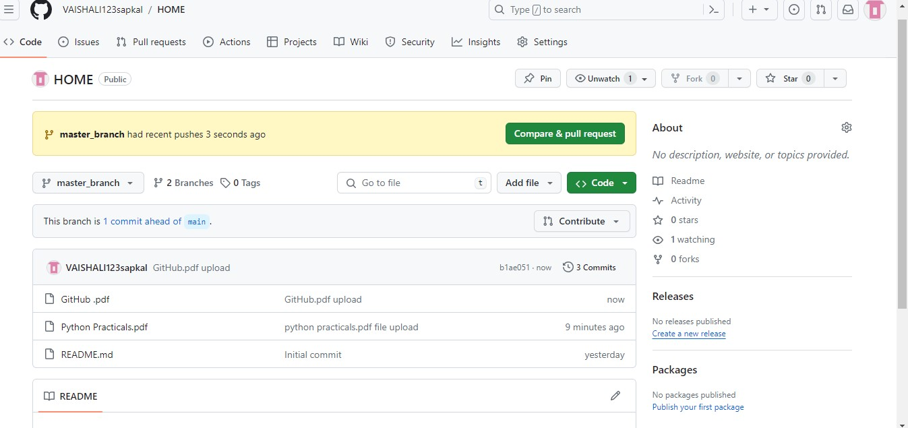

**Performing Pull request:**

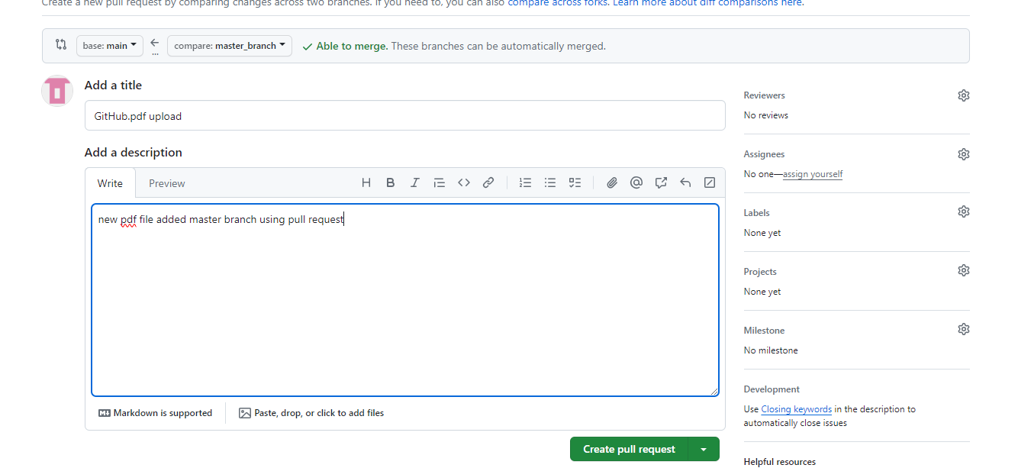

**After Pull performing merge on remote repository at primary branch(main)on remote repository:**

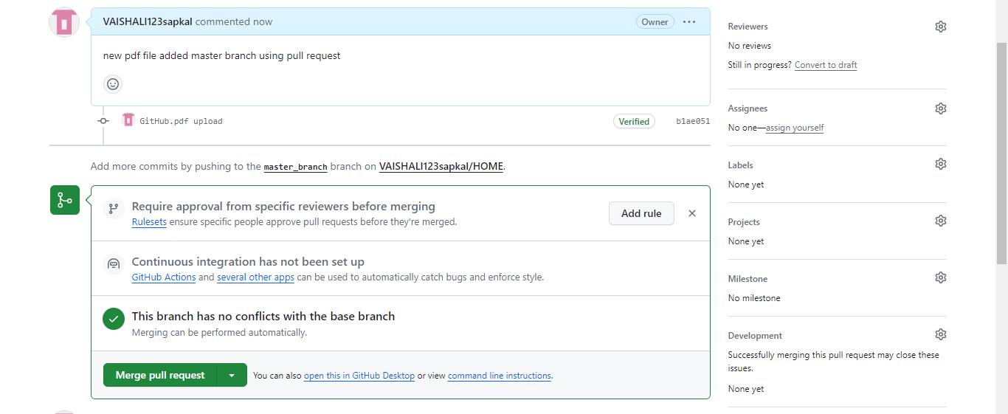

**After Merge from branch2 to primary branch(master)on remote repository:**

